

**Name: Muhammad Sudais Khalid**

**Reg.No: BSAI-23F-0050**

**Project Title: STMU Airline Management System**

**Program: BS Artificial Intelligence**

**Semester: 03**

**Subject: DSA Lab**

**Date: 26/01/2025**

**Submitted to: Sir Talha Mehmood**

Table of Contents

1. ABSTRACT 2

2. ACKNOWLEDGEMENT 3

3. LIST OF FIGURES 3

Figure 1: Flight Route Representation in Graph 3

Figure 2: GUI Design Overview 3

Figure 3: System Architecture 4

4. LIST OF TABLES 4

Table 1: Flight Data Sample 4

Table 2: Booking Records Sample 4

Table 3: Gantt Chart Activities 4

5. INTRODUCTION 5

5.1 Introduction 5

5.2 Problem Statement 5

5.3 Objectives 5

6. LITERATURE REVIEW / THEORY 5

6.1 Background of Study 5

6.2 Understanding of the Problem 5

7. METHODOLOGY 5

7.1 Project Work & Research Methodology 5

7.2 Tools 5

7.3 Activities/Gantt Chart and Milestones 6

8. RESULT & DISCUSSION 6

8.1 Data Structures involved in the Project and their Implementation 6

8.2 Architecture and Working of the Project (Advantages/Limitations) 6

8.3 Language used in the Project with Code 6

8.4 Modules of the Project 6

9. CONCLUSION & FUTURE WORK 7

9.1 Conclusion 7

9.2 Future Work 7

10. REFERENCES 7

11. CODE 7

# 1. ABSTRACT

This project report presents the development of the **STMU Airline Management System**, a Java-based desktop application designed to streamline the airline service process. This system incorporates data structures such as graphs, hash maps, queues, and lists to manage flight routes, bookings, and passenger information efficiently. With a user-friendly GUI created using Swing, the project simulates real-world airline operations, including adding flights, booking tickets, viewing routes, and processing reservations. The application also features secure login functionality.

The report elaborates on the problem statement of manual inefficiencies in airline management and presents objectives such as improving data handling and user experience. Key components of the system include flight route management, booking processing, and data storage using files for persistence. The methodology section highlights tools like IntelliJ IDEA and Java SE. Implementation details discuss data structures used, project architecture, and modular design, offering insights into system advantages and limitations. Future work aims to enhance functionality by incorporating cloud-based databases and real-time flight tracking. This document is a comprehensive account of the project's objectives, methods, results, and future scope.

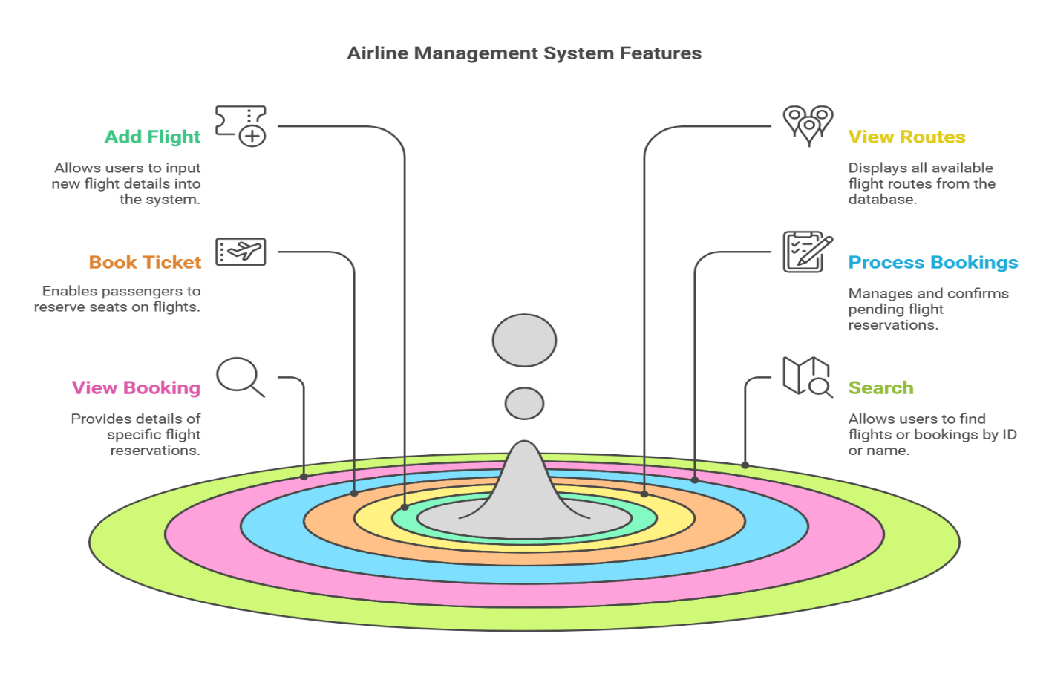

# 2. ACKNOWLEDGEMENT

I would like to express my sincere gratitude to my instructor, Talha Mahmood, for his guidance and support throughout this project. I am also thankful to my peers and the faculty members of the Department of Computing for their valuable insights and encouragement. Finally, I extend my heartfelt thanks to my family and friends for their unwavering support during this academic Endeavor.

# 3. LIST OF FIGURES

## Figure 1: Flight Route Representation in Graph

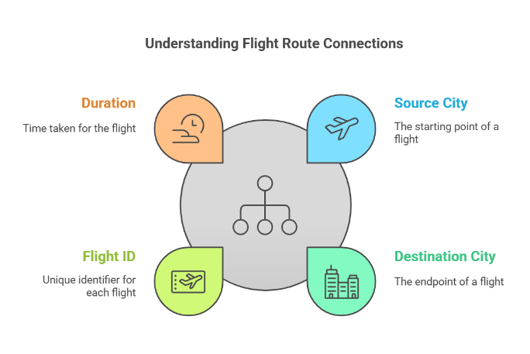

## Figure 2: GUI Design Overview

## 

## Figure 3: System Architecture

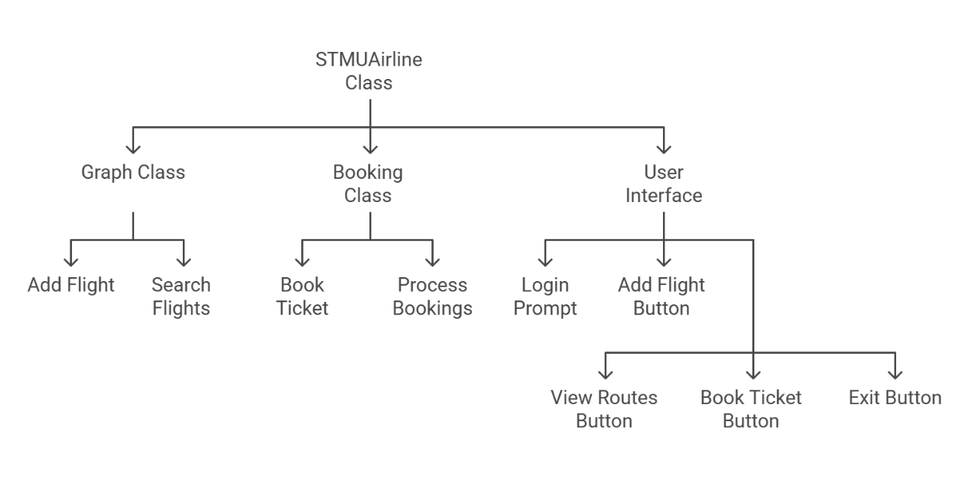

# 

# 4. LIST OF TABLES

## Table 1: Flight Data Sample

|  |  |  |  |
| --- | --- | --- | --- |
| **Source** | **Destination** | **Flight ID** | **Duration (Min)** |
| Islamabad | London | PK001 | 300 |
| Karachi | Gawadhar | PK002 | 120 |

## Table 2: Booking Records Sample

|  |  |  |
| --- | --- | --- |
| **Booking ID** | **Passenger Name** | **Flight ID** |
| Islamabad | London | 300 |
| Karachi | Gawadhar | 120 |

## Table 3: Gantt Chart Activities

|  |  |  |
| --- | --- | --- |
| **Activity** | **Date** | **Status** |
| Requirement Gathering | 05-12-2024 | Completed |
| System Design | 10-12-2024 | Completed |
| Implementation | 01-01-2025 | Completed |
| Testing & debugging | 18-01-2025 | Completed |
| Report Writing | 24-01-2025 | Completed |

# 5. INTRODUCTION

## 5.1 Introduction

Airline management is a complex process requiring efficient handling of flight schedules, bookings, and passenger records. The **STMU Airline Management System** aims to address these challenges using a Java-based solution that leverages data structures for optimal performance and data persistence for reliability.

## 5.2 Problem Statement

Current manual systems for airline management are prone to inefficiencies, data errors, and a lack of real-time accessibility. This project focuses on automating these processes to enhance operational efficiency and user experience.

## 5.3 Objectives

1. Develop a desktop application to manage airline operations efficiently.
2. Implement secure login and an intuitive GUI for user interaction.
3. Use advanced data structures for flight and booking management.

# 6. LITERATURE REVIEW / THEORY

## 6.1 Background of Study

With the rise of digital systems, manual airline management methods have become obsolete. Efficient software solutions are necessary to handle the complexity of flight scheduling and reservations.

## 6.2 Understanding of the Problem

This project identifies issues in traditional systems, such as lack of data integrity and high operational costs and proposes a structured software solution to address them.

# 7. METHODOLOGY

## 7.1 Project Work & Research Methodology

The project follows an agile methodology, with iterative development cycles to ensure modularity and scalability.

## 7.2 Tools

* Programming Language: Java
* IDE: IntelliJ IDEA
* Libraries: Swing, Java Collections Framework
* File Handling: Buffered Reader, Buffered Writer

## 7.3 Activities/Gantt Chart and Milestones

|  |  |  |
| --- | --- | --- |
| **Activity** | **Date** | **Status** |
| Requirement Gathering | 05-12-2024 | Completed |
| System Design | 10-12-2024 | Completed |
| Implementation | 01-01-2025 | Completed |
| Testing & debugging | 18-01-2025 | Completed |
| Report Writing | 24-01-2025 | Completed |

# 8. RESULT & DISCUSSION

## 8.1 Data Structures involved in the Project and their Implementation

* Graphs: Used for flight route representation.
* Hash Maps: For storing bookings and flight data.
* Queues: For managing booking processes.
* Lists: For searching and retrieving data.

## 8.2 Architecture and Working of the Project (Advantages/Limitations)

* **Advantages:** modular design, efficient data handling, and user-friendly GUI.
* **Limitations:** Limited to local file storage; no real-time data updates.

## 8.3 Language used in the Project with Code

The project is implemented entirely in Java, utilizing data structures and algorithms (DSA) concepts such as graphs, hash maps, queues, and lists for efficient management of flight routes and bookings. Refer to Section 11 for the complete source code.

## 8.4 Modules of the Project

1. Flight Management
2. Booking System
3. Login and Authentication
4. Data Storage and Retrieval

# 9. CONCLUSION & FUTURE WORK

## 9.1 Conclusion

The **STMU Airline Management System** demonstrates the potential of Java-based solutions in streamlining airline operations. The project effectively manages flight and booking data, ensuring reliability and user satisfaction.

## 9.2 Future Work

1. Integrating cloud-based databases for scalability.
2. Adding real-time flight tracking.
3. Enhancing GUI with modern frameworks.

# 10. REFERENCES

1. "Java: The Complete Reference" by Herbert Schildt
2. Hash Map Concept Tutorial ( <https://youtu.be/W5q0xgxmRd8?si=lzyFbGcIjOx-Dg-b> )
3. Swing Tutorials (<https://docs.oracle.com/javase/tutorial/uiswing/>)

## 11. CODE

# [Click Here for Source Code](https://drive.google.com/file/d/12n6fhz9KWJtRh_8z0moJokskW2cOh60P/view?usp=sharing)